**Final Year B. Tech., Sem VII 2022-23**

**Cryptography And Network Security**

**PRN: 2020BTECS00206**

**Full Name: SAYALI YOGESH DESAI**

**Batch: B4**

**Assignment No. 3**

1. **Aim:**

Encrypt the given plain text using Playfair Encryption Algorithm.

1. **Theory:**

The Algorithm consists of 2 steps:

**Generate the key Square (5×5):**

* + - * The key square is a 5×5 grid of alphabets that acts as the key for encrypting the plaintext. Each of the 25 alphabets must be unique and one letter of the alphabet (usually J) is omitted from the table (as the table can hold only 25 alphabets). If the plaintext contains J, then it is replaced by I.
* The initial alphabets in the key square are the unique alphabets of the key in the order in which they appear followed by the remaining letters of the alphabet in order.

**Algorithm to encrypt the plain text:**

The plaintext is split into pairs of two letters (digraphs). If there is an odd number of letters, a Z is added to the last letter.

**For example:**

**Plain Text**: "instruments"

**After Split:** 'in' 'st' 'ru' 'me' 'nt' 'sz'

**1.**Pair cannot be made with same letter. Break the letter in single and add a bogus letter to the previous letter.

**Plain Text:**“hello”

**After Split:**‘he’ ‘lx’ ‘lo’

Here **‘x’**is the bogus letter.

**2.**If the letter is standing alone in the process of pairing, then add an extra bogus letter with the alone letter

**Plain Text:**“helloe”

**After Split:**‘he’ ‘lx’ ‘lo’ ‘ez’

Here **‘z’** is the bogus letter.

**\*Rules for Encryption:**

1. **If both the letters are in the same column**: Take the letter below each one (going back to the top if at the bottom).
2. **If both the letters are in the same row**: Take the letter to the right of each one (going back to the leftmost if at the rightmost position).
3. **If neither of the above rules is true**: Form a rectangle with the two letters and take the letters on the horizontal opposite corner of the rectangle.
4. **Code:**

#include<bits/stdc++.h>

using namespace std;

map<char,pair<int,int>> charPos;

// Capitalize the character

void capitalize(string &str){

for(char &c:str){

if(c>=97 && c<=122)

c-=32;

}

}

// add char pairs to the set

void addToSet(vector<pair<char,char>> &v,char a,char b){

v.push_back({a,b});

}

// build matrix

void buildMatrix(vector<vector<char>> &mat,string key){

vector<bool>vis(26,false);

int i=0,j=0;

for(int k=0;k<key.length();k++){

if(!vis[key[k]-65]){

mat[i][j]=key[k];

if(key[k]=='I'||key[k]=='J'){

vis['I'-65]=true;

vis['J'-65]=true;

}

else vis[key[k]-65]=true;

j++;

if(j==5){

j%=5;

i++;

}

}

}

for(int k=0;k<26;k++){

if(!vis[k]){

if(k+'A'=='I'||k+'A'=='J'){

vis['I'-65]=true;

vis['J'-65]=true;

}

mat[i][j]=k+'A';

j++;

if(j==5){

j%=5;

i++;

}

}

}

// cout<<"\n \nMatrix:\n";

for(int i=0;i<5;i++){

for(int j=0;j<5;j++){

cout<<mat[i][j]<<" ";

}

cout<<'\n';

}

}

void encrypt(vector<vector<char>> &mat,vector<pair<char,char>> &pairSet){

// storing position of chars in the matrix

for(int i=0;i<5;i++){

for(int j=0;j<5;j++)

if(mat[i][j]=='I' || mat[i][j]=='J')

charPos['J']=charPos['I']=make_pair(i,j);

else

charPos[mat[i][j]]=make_pair(i,j);

}

// print

cout<<"\n";

// cout<<"Plain Text:";

for(auto it:pairSet)

cout<<it.first<<it.second<<" ";

cout<<endl;

// cout<<"Cypher Text: ";

for(auto &it:pairSet){

int i1=charPos[it.first].first;

int j1=charPos[it.first].second;

int i2=charPos[it.second].first;

int j2=charPos[it.second].second;

if(i1==i2){

it.first=mat[i1][(j1+1)%5];

it.second=mat[i1][(j2+1)%5];

cout<<mat[i1][(j1+1)%5]<<mat[i1][(j2+1)%5]<<" ";

}

else if(j1==j2){

it.first=mat[(i1+1)%5][j1];

it.second=mat[(i2+1)%5][j2];

cout<<mat[(i1+1)%5][j1]<<mat[(i2+1)%5][j2]<<" ";

}

else{

it.first=mat[i1][j2];

it.second=mat[i2][j1];

cout<<mat[i1][j2]<<mat[i2][j1]<<" ";

}

}

cout<<"\n\n";

}

void decrypt(vector<vector<char>> &mat,vector<pair<char,char>> &pairSet){

// print

// for(auto it:charPos)

// cout<<it.first<<" "<<it.second.first<<" "<<it.second.second<<endl;

// cout<<endl;

// cout<<"Plain Text: ";

for(auto it:pairSet){

int i1=charPos[it.first].first;

int j1=charPos[it.first].second;

int i2=charPos[it.second].first;

int j2=charPos[it.second].second;

// cout<<i1<<j1<<" "<<i2<<j2<<endl;

if(i1==i2){

cout<<mat[i1][((j1-1)+5)%5]<<mat[i1][((j2-1)+5)%5]<<" ";

}

else if(j1==j2){

cout<<mat[((i1-1)+5)%5][j1]<<mat[((i2-1)+5)%5][j2]<<" ";

}

else{

cout<<mat[i1][j2]<<mat[i2][j1]<<" ";

}

}

}

int main(){

freopen("playfairInput.txt", "r", stdin);

freopen("playfairOutput.txt", "w", stdout);

string tmp,key,plainText;

vector<pair<char,char>> pairSet;

getline(cin,tmp);

for(char c:tmp){

if(c!=32)

plainText.push_back(c);

}

// cout<<plainText<<endl;

capitalize(plainText);

getline(cin,key);

capitalize(key);

// cout<<key<<endl;

int n=plainText.size();

for(int i=0;i<n;){

char a=plainText[i];

if(i==n-1 || plainText[i+1]==a){

addToSet(pairSet,a,'X'); // added if x as dummy for same chars

i++;

}

else{

addToSet(pairSet,a,plainText[i+1]);

i+=2;

}

}

// breaking the plain text into 2chars

// for(auto it:pairSet)

// cout<<it.first<<it.second<<" ";

// build matrix

vector<vector<char>> mat(5,vector<char>(5));

buildMatrix(mat,key);

// Encrypt the text

// cout<<"Encryption\n";

encrypt(mat,pairSet);

// Decrypt the Cypher Text

// cout<<"Decryption\n";

decrypt(mat,pairSet);

}

1. **Input:**

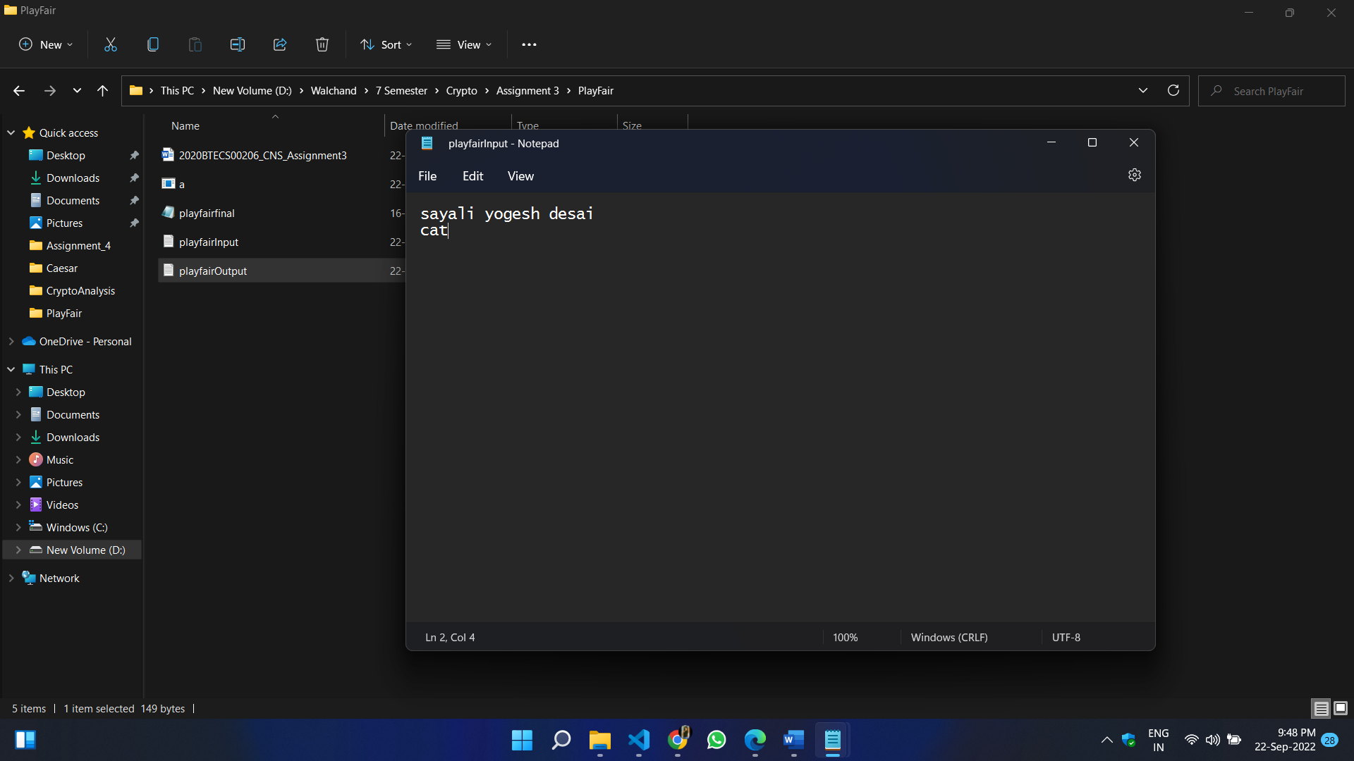

1. **Output:**

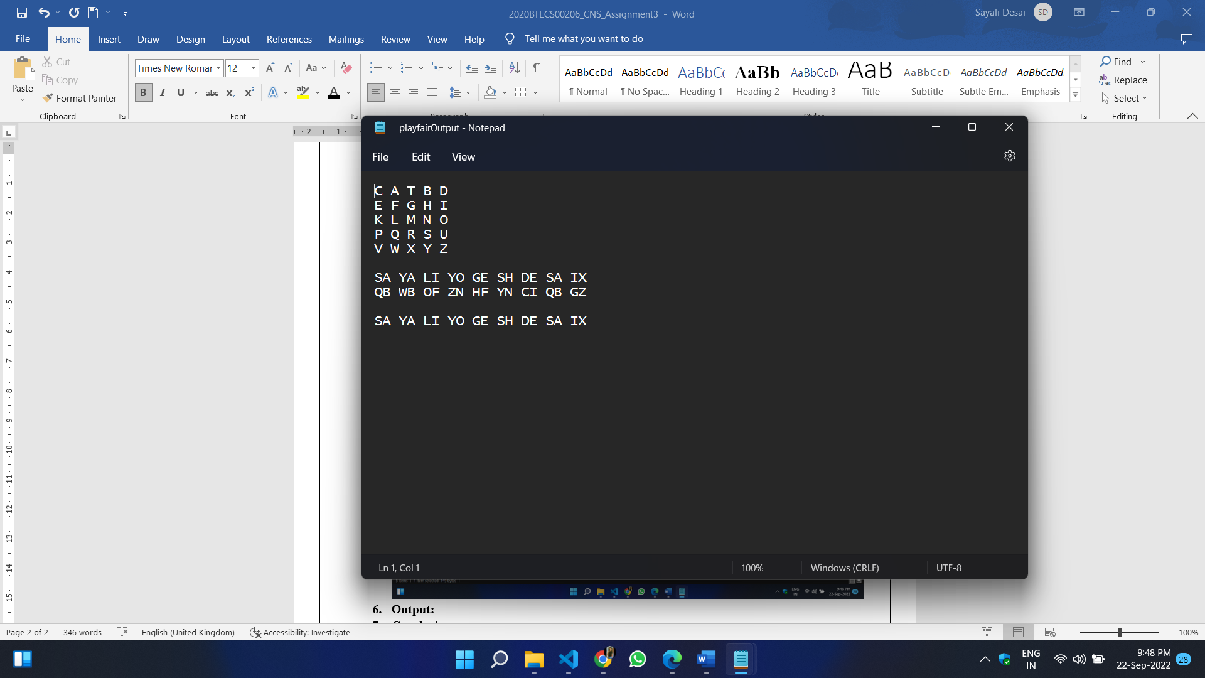

1. **Conclusion:**

I have successfully encrypted the plain text using play fair encryption algorithm followed by all the rules and regulations.